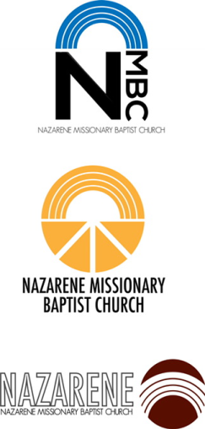

Request Submitted by (name)

Contact Info (phone number) email

***Approvals***

1) 2)

NMBC Credit Card Transaction

Card Used ***(check one)***

|  |  |  |  |
| --- | --- | --- | --- |
|  | Administrative / Office Card |  | Christian Ministries / Precept Classes |
|  |  |  |  |
|  | Bus Ministry Card |  | Executive Support / Board Card |

***Note: A Receipt must be attached to the voucher when an advance payment is made by cash, check or credit card.***

Cash Transaction

Date: Check Number:

Signature of Person Making the Debt

Date: Amount Requested:

Organization: Budget Account Number:

Purpose of Disbursement:

Make Check Payable To:

Address

City State Zip

Disbursement Requisition, Voucher / Reimbursement Form

Nazarene Missionary Baptist Church